A Student’s Guide to Using TEAMS

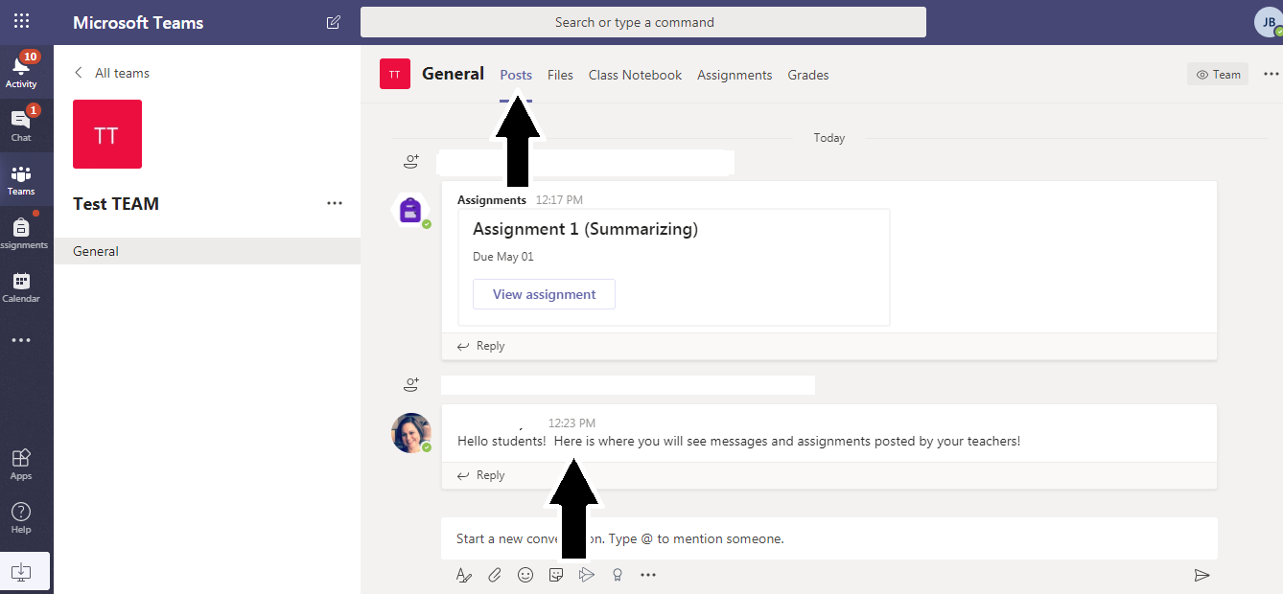
Posts: Here you will see messages from your teachers and assignments that he or she created.

Files: Here you can find files that your teacher uploads.
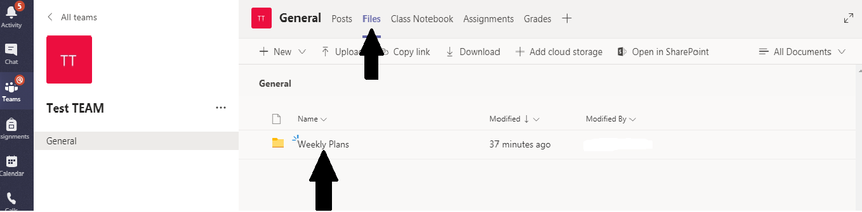

Assignments: Here you will see all of the assignments your teacher has given you along with any resources or instructional videos.

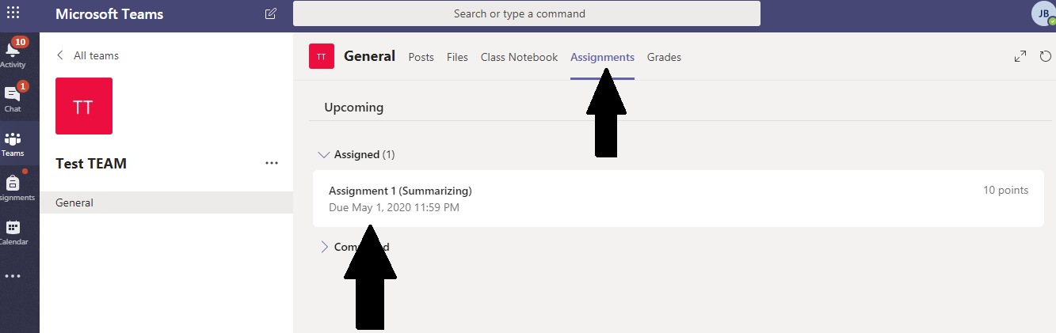

Grades: Here you will see all of your assignments along with the grades and teacher feedback.

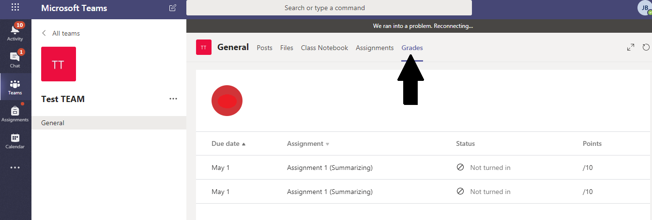

How to Complete an Assignment from a Desktop Computer

Step 1: Click on the assignment you want to complete.

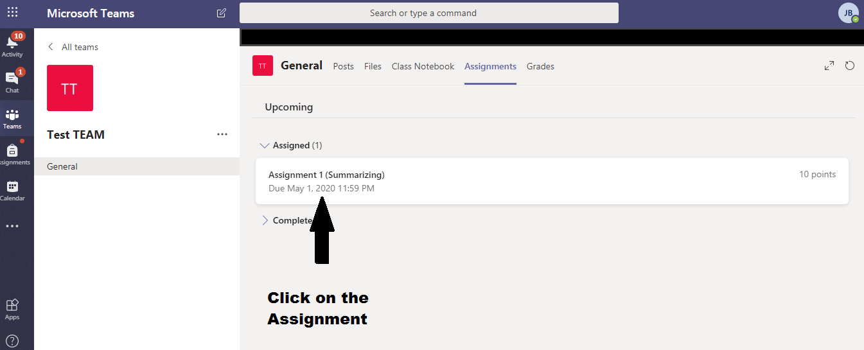

Step 2: Click the assignment under “My Work.”

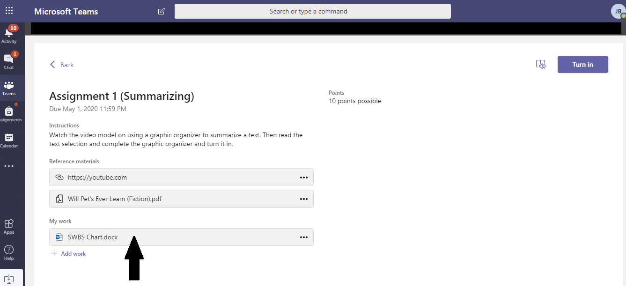

Step 3: Click “Edit Document” and select either option.

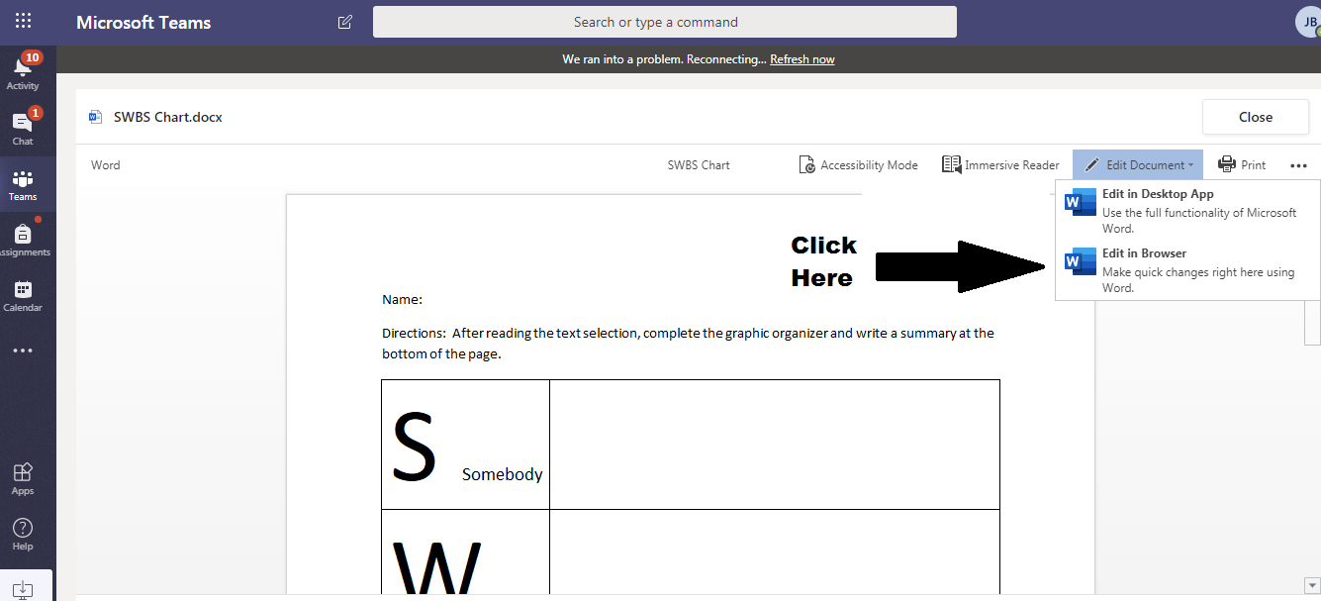

Step 4: Complete the work. The document will save automatically without the need to hit the “Save” button.

Step 5: Close the document when you have finished.

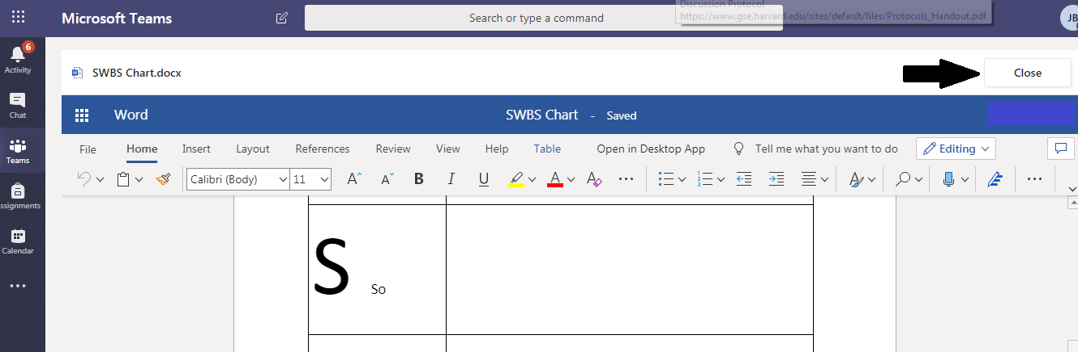

Step 6: Turn it in for your teacher to assess and give you feedback!

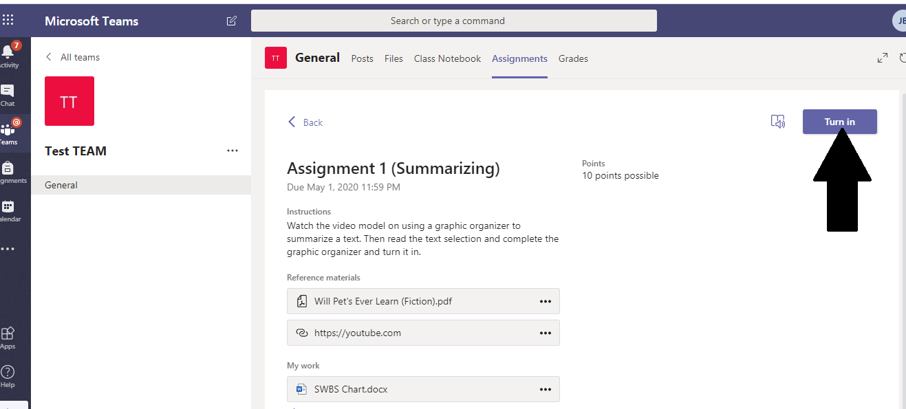

Step 7: Enjoy your virtual learning experience using TEAMS!

How to Complete an Assignment from a Mobile Device

Step 1: Download the TEAMS app onto your mobile device, and log in using your district log-in information provided by your teacher.

Step 2: Download the Microsoft Word app onto your mobile device. This is where you will complete your assignments.

Step 3: Click on the assignment you want to view.

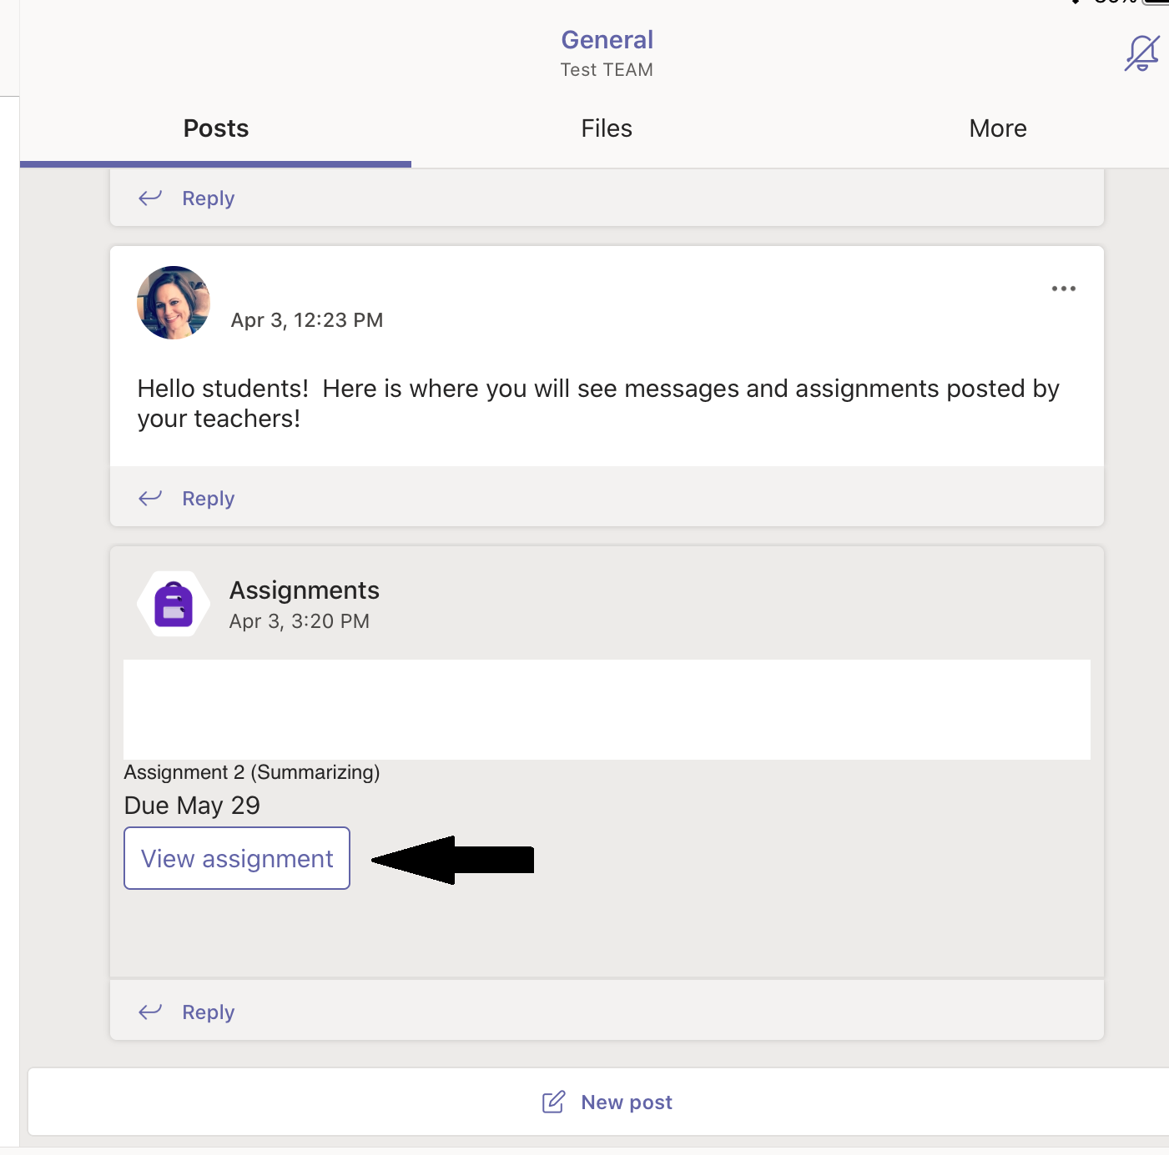

Step 4: Select the assignment to be completed under “My Work.” 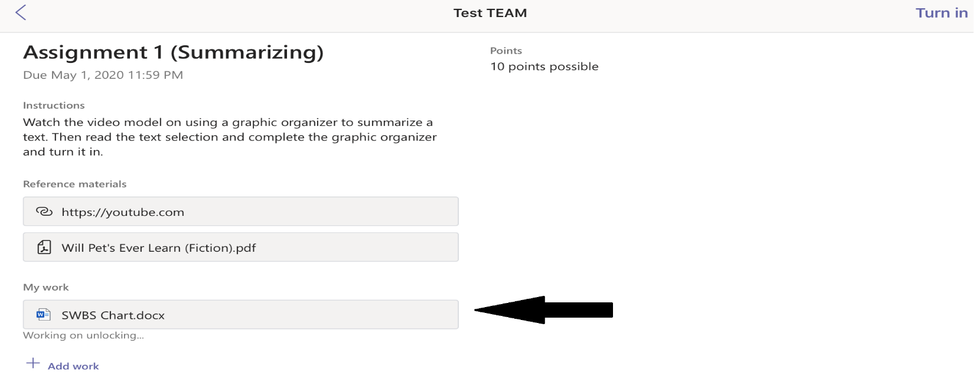

Step 5: Click the icon at the top right of the assignment.

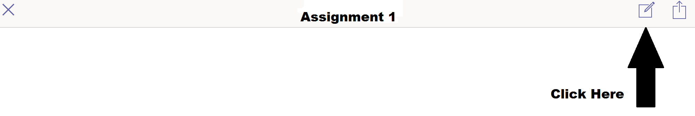

Step 6: Microsoft Office will open your document. You will type directly onto the document.

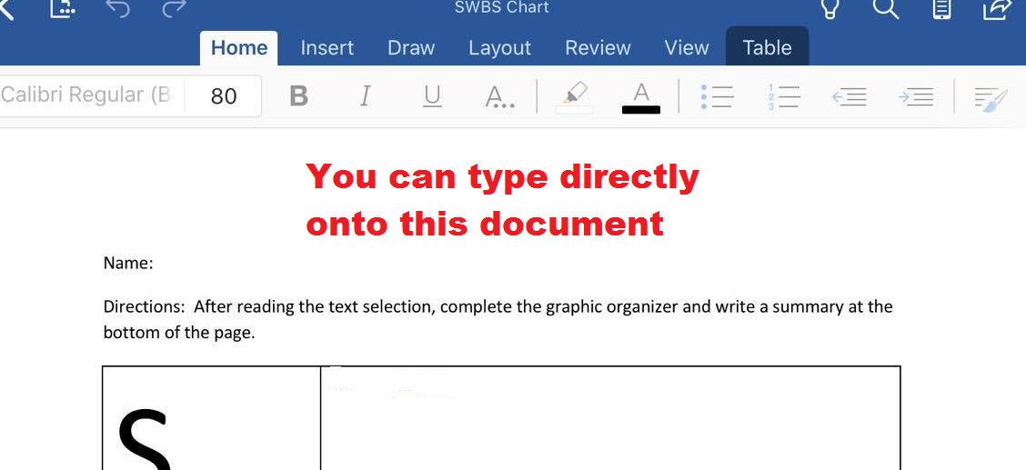

Step 7: Complete the work. The document will save automatically without the need to hit the “Save” button. Just make sure the AutoSave button is on.

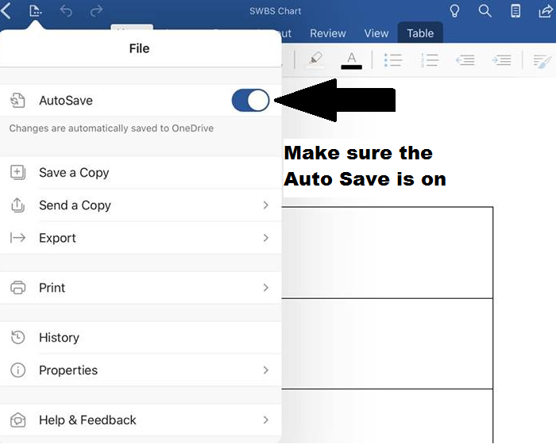
Step 8: Turn it in for your teacher to assess and give you feedback. You can also attach other documents and pictures to the assignment you are turning in by clicking, “Add Work.”

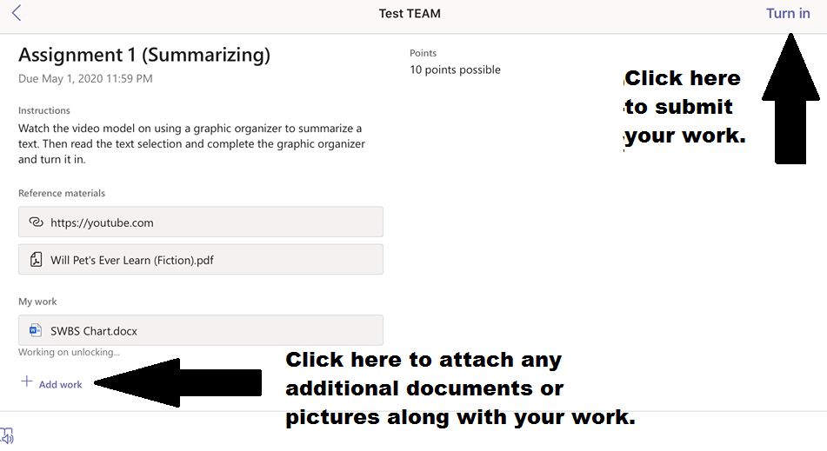

Step 9: Enjoy your virtual learning experience using TEAMS on your mobile device!

